**Summary:**

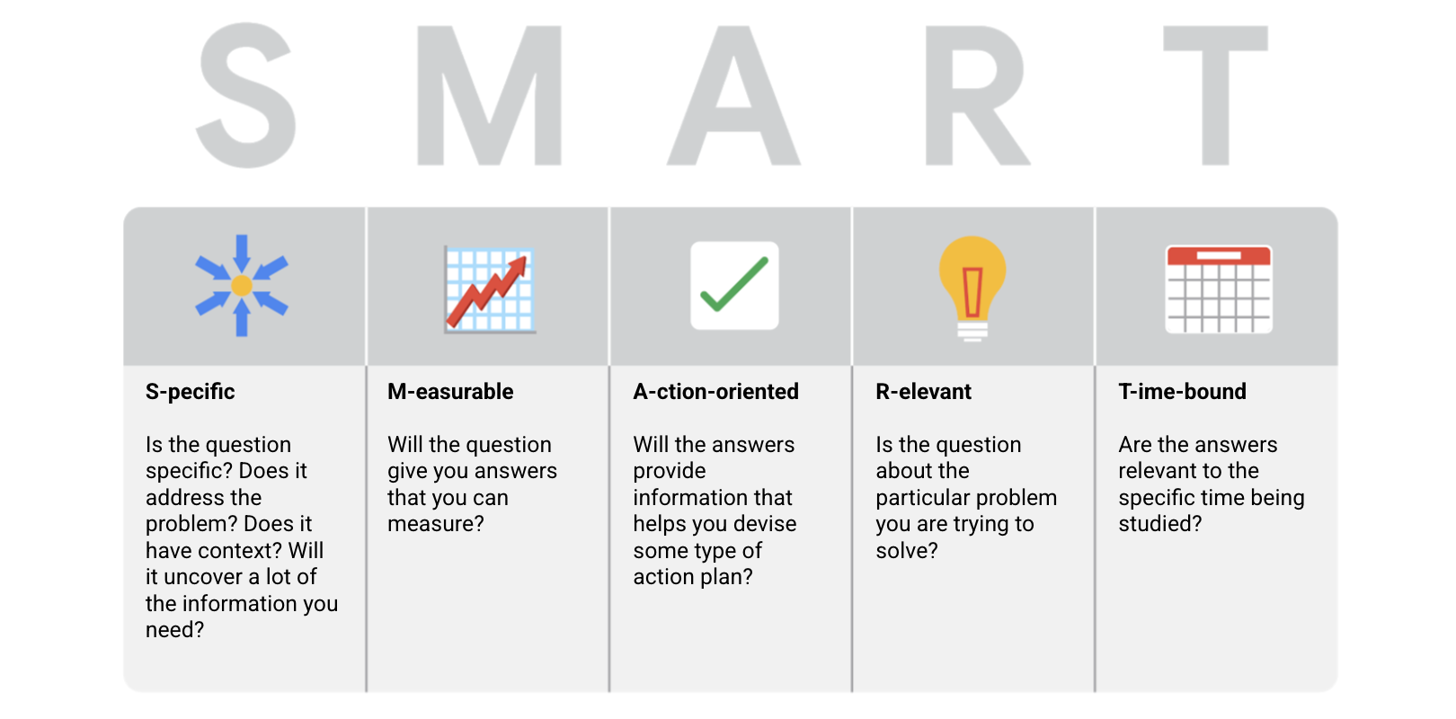

* ***Specific****: Does the question focus on a particular car feature?*
* ***Measurable****: Does the question include a feature rating system?*
* ***Action-oriented****: Does the question influence creation of different or new feature packages?*
* ***Relevant****: Does the question identify which features make or break a potential car purchase?*
* ***Time-bound****: Does the question validate data on the most popular features from the last three years?*

**Things to avoid when asking questions:**

**Leading questions**: questions that only have a particular response

* Example: **This product is too expensive, isn’t it?**

**Closed-ended questions**: questions that ask for a one-word or brief response only

* Example: **Were you satisfied with the customer trial?**

**Vague questions:** questions that aren’t specific or don’t provide context

* Example: **Does the tool work for you?**

## **The scenario**



You are three weeks into your new job as a junior data analyst. The company you work for has just collected data on their weekend sales. Your manager asks you to perform a “deep dive” into this data. To get this project started, you must ask some questions and get some information.

## **Reflection**



Consider the scenario above:

* Based on the SMART framework, which questions are most important to ask?
* How will these questions clarify the requirements and goals for the project?
* How does asking detailed, specific questions benefit you when planning for a project? Can vague or unclear questions harm a project?

Now, write 2-3 sentences (40-60 words) in response to each of these questions. Type your response in the text box below.

*RESPONSE:*

Some of the most important questions are:

> Who are the stakeholders, who might need this information and what should I specifically draw from the data?

> How much time do I have to complete the project?

> Do I need to make report, visualization, presentation or all of them

> If there is another source of data?

If we know who the stakeholders are we can fetch their background information and prepare the reports and visualization according to their understanding. For example an experienced businessman might understand a data analyst's perspective quicker than a newcomer. We need to understand the data so as not to mess up in later stages

Asking detailed questions helps us manage our efforts and time to the best of its value. If we know the due date, understand stakeholder expectations, understand the data and context it'll be easier on the data analyst to figure out how he should approach.

## ***Reflection***



*Before you begin your conversation about data, consider each of the above steps. Think about potential candidates, brainstorm some SMART questions, and get an idea of the information you want to record during your conversation. Then, reflect on your conversation:*

* *What SMART questions did you ask? How did these questions tie into the field of the person you chatted with?*
* *What insights did you discover during your conversation?*
* *How did the SMART framework help you arrive at your conclusions?*

*Now, write 2-3 sentences (40-60 words) in response to each of these questions. Type your response in the text box below.*

*RESPONSE:*

So I called my friend Y*** we're in the same grade, 3rd year BTech AI. He's also aspiring to be a data scientist. I asked him about his career choice and how he landed in conclusion.

Here's how I phrased the questions?

1) Out of all the jobs available, why doyou want to be a data scientist?

2) Why don't you play online games like Valorant?

3) What future plans do you have regarding internship and job/ higher studies?

4) What subject is he looking forward to learning this semester?

These questions gave me an understanding of how he thinks about things. I found out that he relies on data to make his decisions. His prime motivation for becoming a data scientist was, "It's the sexiest job of the century, pays well, well respected. What else do you need?"

I learnt to ask specific questions, like the first question emphasizes on Data Scientist rather than all jobs, second focuses on Valorant rather than all games, etc. I grouped subjects as a whole and let him choose what he'd like to learn instead of saying "would you enjoy Computer Vision this semester?"

A data analyst uses the SMART methodology to create a question that encourages change. This type of question can be described how : ***Action-oriented***

A time-bound SMART question specifies which of the following parameters : ***The era, phase, or period of analysis***

A data analyst working for a mid-sized retailer is writing questions for a customer experience survey. One of the questions is: “Do you prefer online or in-store?” Then, they rewrite it to say: “Do you prefer shopping at our online marketplace or shopping at your local store?” Describe why this is a more effective question : ***The first question is vague, whereas the second question includes important context.***

A data analyst at a social media company is creating questions for a focus group. They use common abbreviations such as PLS for “please” and LMK for “let me know.” This is fair because the participants use social media a lot and are likely to be technically savvy.: ***False***

*Examples:*

*For instance, if you have a conversation with someone who works in retail, you might lead with questions like:*

* ***Specific:*** *Do you currently use data to drive decisions in your business? If so, what kind(s) of data do you collect, and how do you use it?*
* ***Measurable:*** *Do you know what percentage of sales is from your top-selling products?*
* ***Action-oriented:*** *Are there business decisions or changes that you would make if you had the right information? For example, if you had information about how umbrella sales change with the weather, how would you use it?*
* ***Relevant:*** *How often do you review data from your business?*
* ***Time-bound:*** *Can you describe how data helped you make good decisions for your store(s) this past year?*

*If you are having a conversation with a teacher, you might ask different questions, such as:*

* ***Specific:*** *What kind of data do you use to build your lessons?*
* ***Measurable:*** *How well do student benchmark test scores correlate with their grades?*
* ***Action-oriented:*** *Do you share your data with other teachers to improve lessons?*
* ***Relevant:*** *Have you shared grading data with an entire class? If so, do students seem to be more or less motivated, or about the same?*
* ***Time-bound:*** *In the last five years, how many times did you review data from previous academic years?*

*If you are having a conversation with a small business owner of an ice cream shop, you could ask:*

* ***Specific:*** *What data do you use to help with purchasing and inventory?*
* ***Measurable:*** *Can you order (rank) these factors from most to least influential on sales: price, flavor, and time of year (season)?*
* ***Action-oriented:*** *Is there a single factor you need more data on so you can potentially increase sales?*
* ***Relevant:*** *How do you advertise to or communicate with customers?*
* ***Time-bound:*** *What does your year-over-year sales growth look like for the last three years?*